Courier Management System

This online application allows both courier management and users to track and update courier status so both will be aware of current location of parcel. This application can be managed by 3 different users describe below

1. Admin: admin can login to system using username and password as ‘admin’. After login admin will add employee details who are responsible to collect courier parcel and update location till deliver. Admin can view list of all couriers and working employees
2. Employee: employee can login to system using username and password given by admin. After login employee will add new courier details and then update its current location details. Employee can view current location of courier on maps.
3. User: employee will give unique courier id to each user and using this ID user can track courier status.

To run project install MYSQL and then open MYSQL console and then copy content from ‘Database.txt’ file and paste in MYSQL console to create database.

Now install python 3.7 and then install all packages given in ‘requirements.txt’ file and then double click on ‘run.bat’ to start python web server and get below page

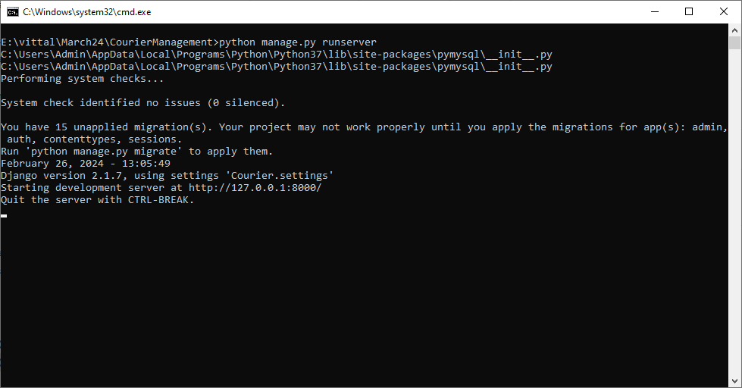

In above screen python server started and now open browser and enter URL as <http://127.0.0.1:8000/index.html> and press enter key to get below page

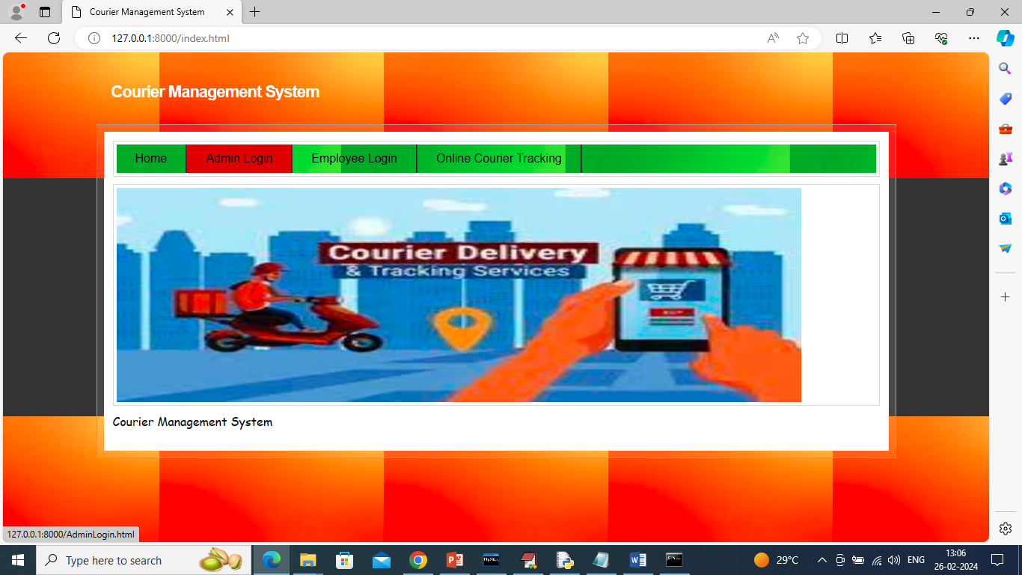

In above screen click on ‘Admin Login’ link to get below login page

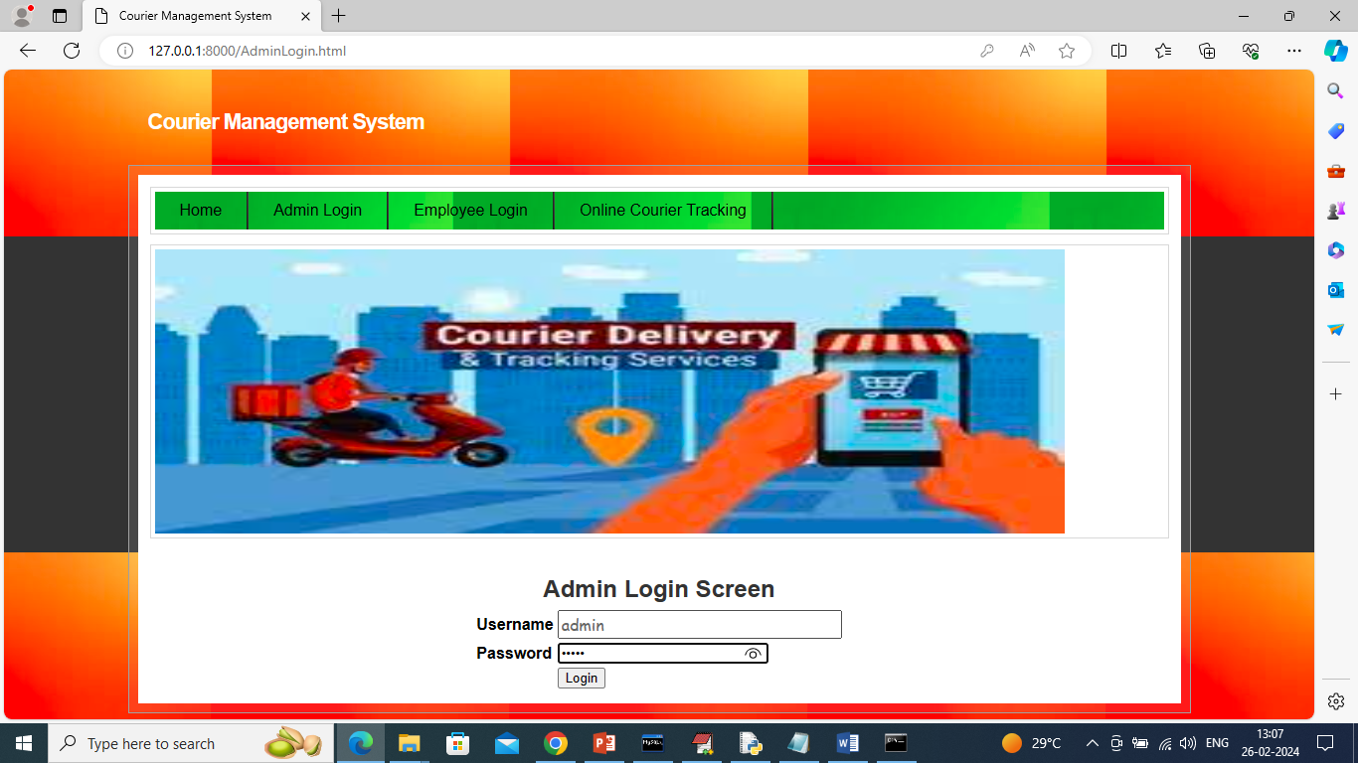

In above screen admin is login and after login will get below page

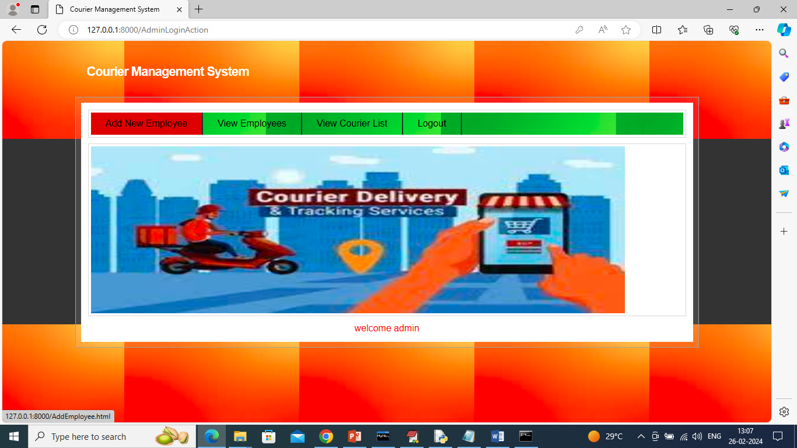

In above screen admin can click on ‘Add New Employee’ link to add employe details and get below page

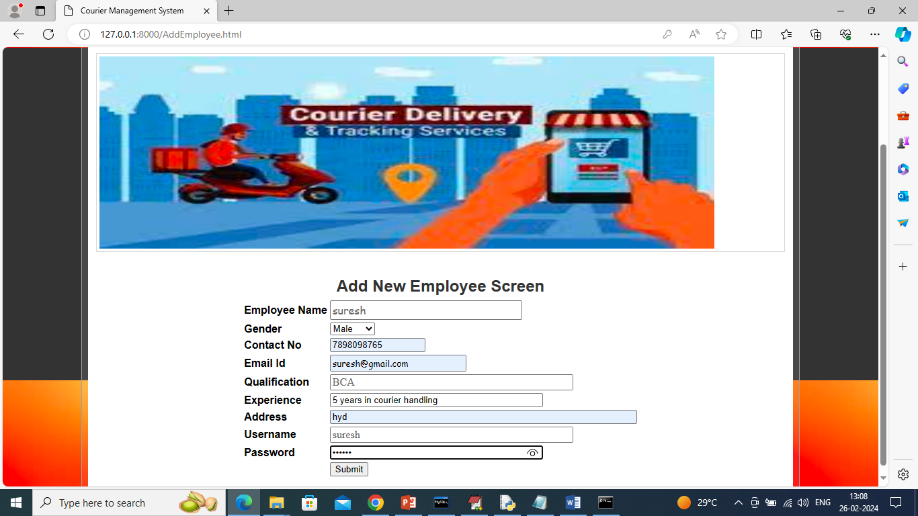

In above screen admin will add employee details and then press button to save details

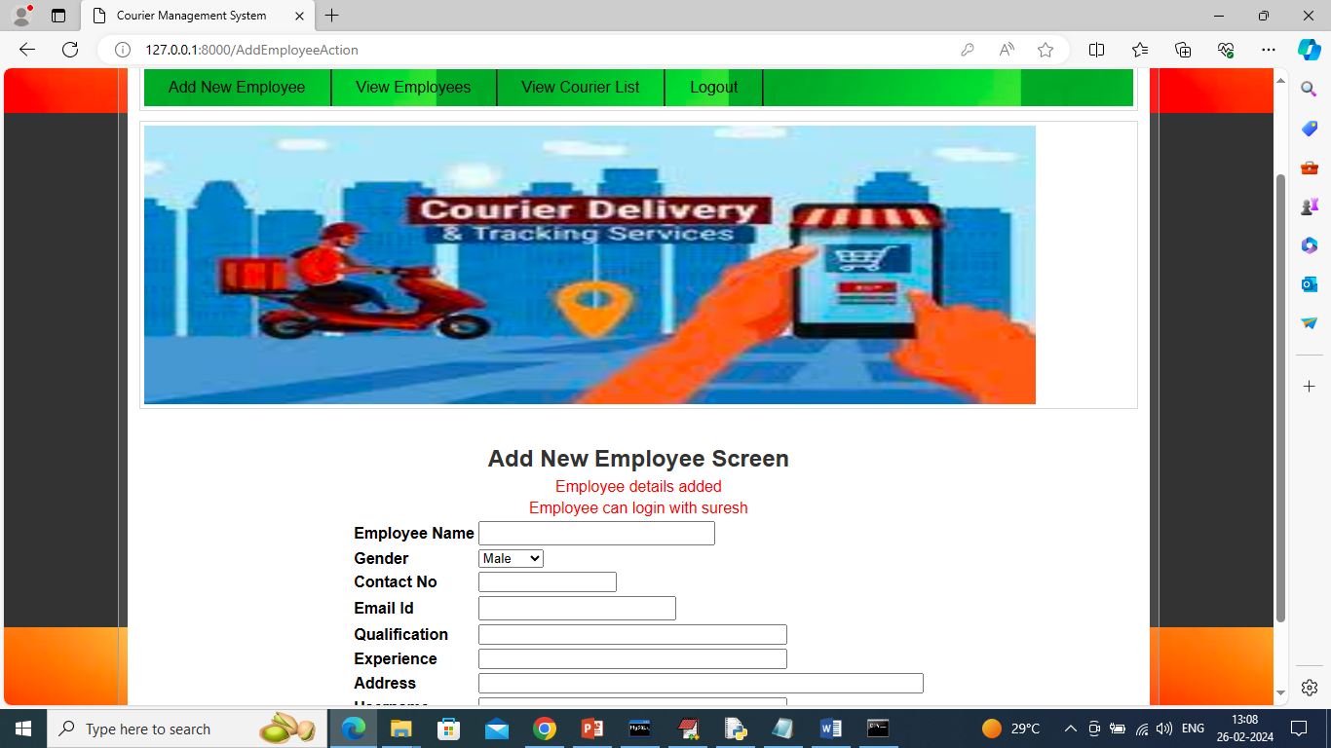

In above screen employee details added to database and by using this login details employee can login to application and now click on ‘View Employee’ link to get list of all available employees

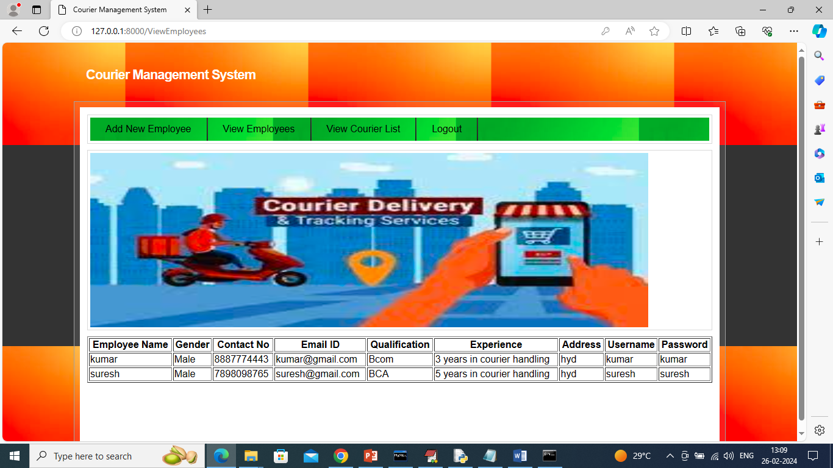

In above screen admin can details of all employees and now click on ‘View Courier List’ to view details of all booked couriers

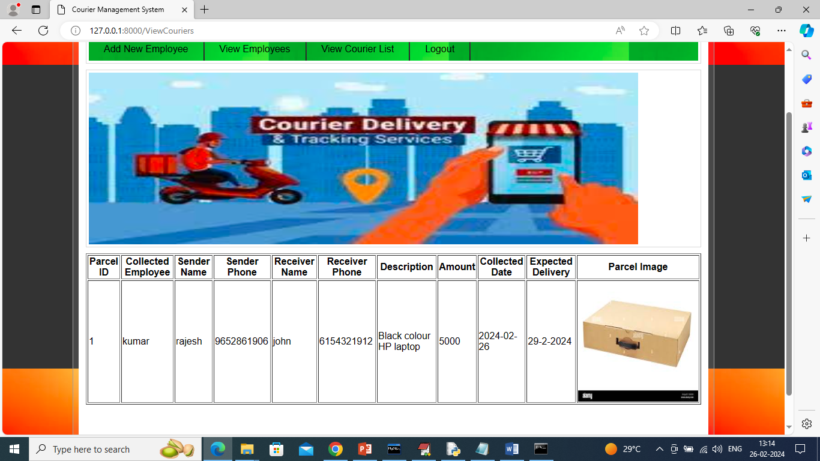

In above screen admin can view list of all booked couriers list and now logout and login as employee

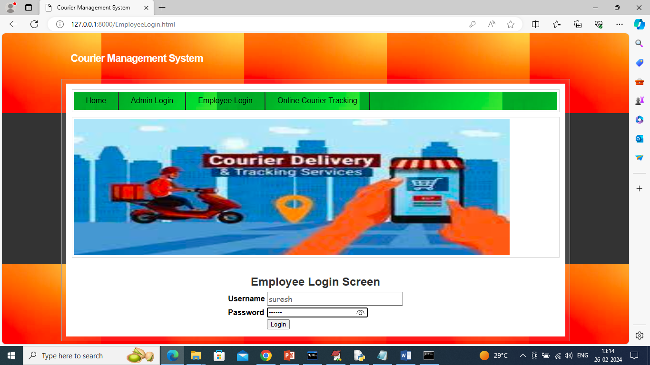

In above screen employee is login and after login will get below page

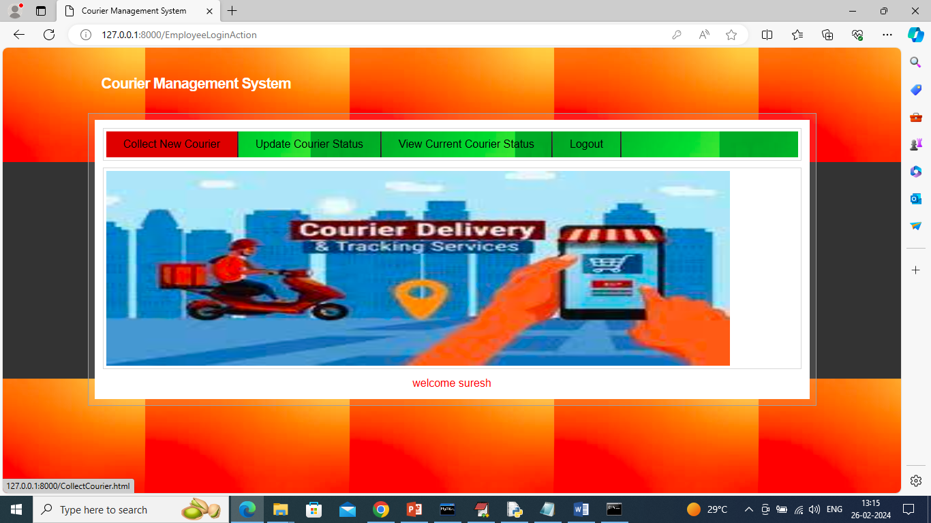

In above screen employee will click on ‘Collect New Courier’ link to add new courier details

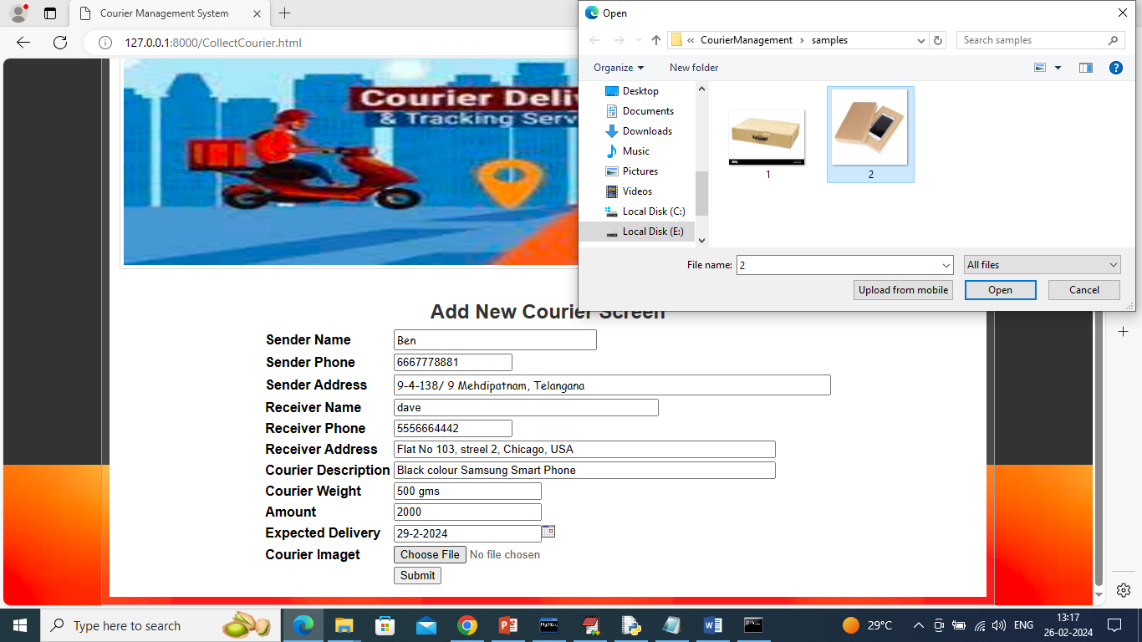

In above screen employee will collect all courier details and then upload courier item image and then press ‘Submit’ button to add new courier details and get below page

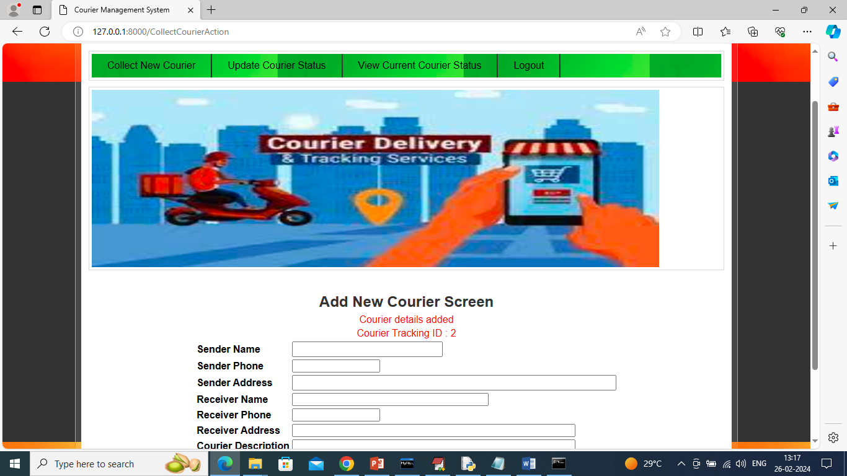

In above screen courier details added and this courier can be tracked using ID as 2 and upon courier progress then employee will click on ‘Update Courier Status’ link to update location and get below page

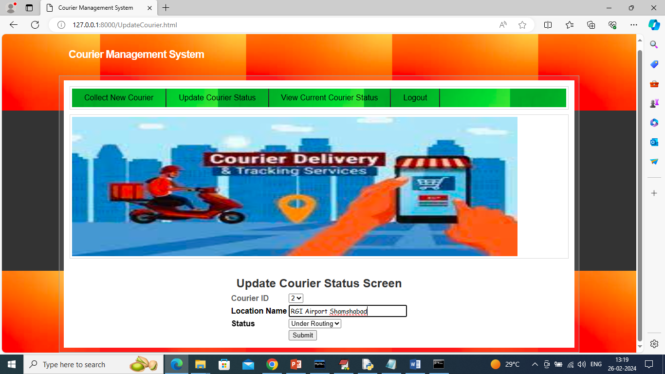

In above screen employee will select courier ID and update current location and this process continues till courier delivered and once delivered then he will update status as ‘Delivered’

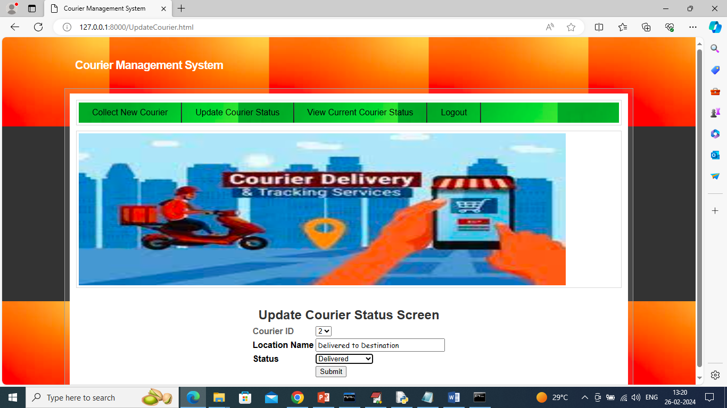

In above screen one courier delivered then employee will choose status as ‘Delivered’ and update its status and now click on ‘View Courier Current Status’ link to get below page

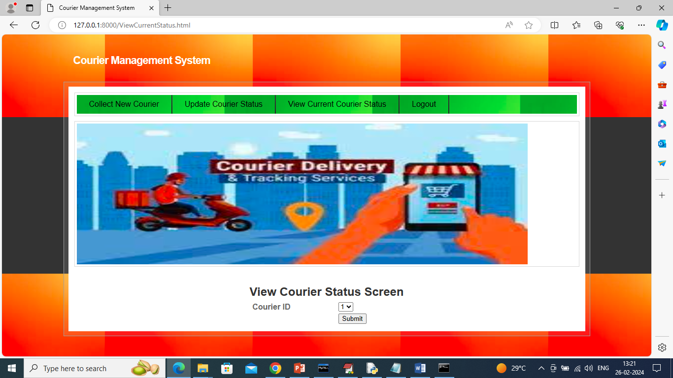

In above screen select courier ID and then click on ‘Submit’ button to get below page

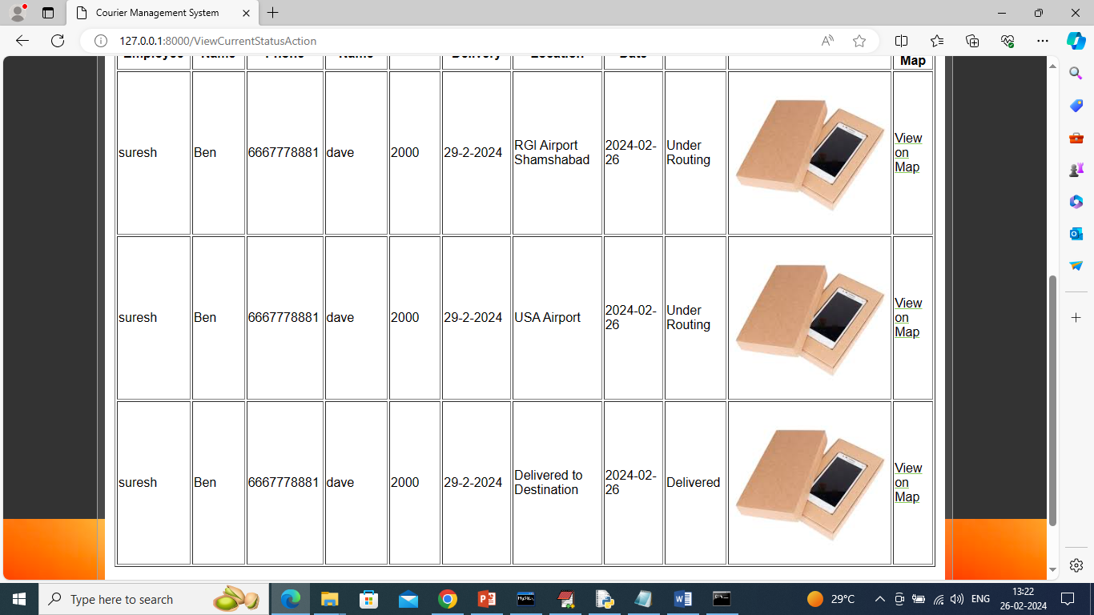

In above screen for selected courier ID employee can see current location and once delivered then status will be shown as ‘Delivered’ and can click on ‘View on Map’ link to get below page

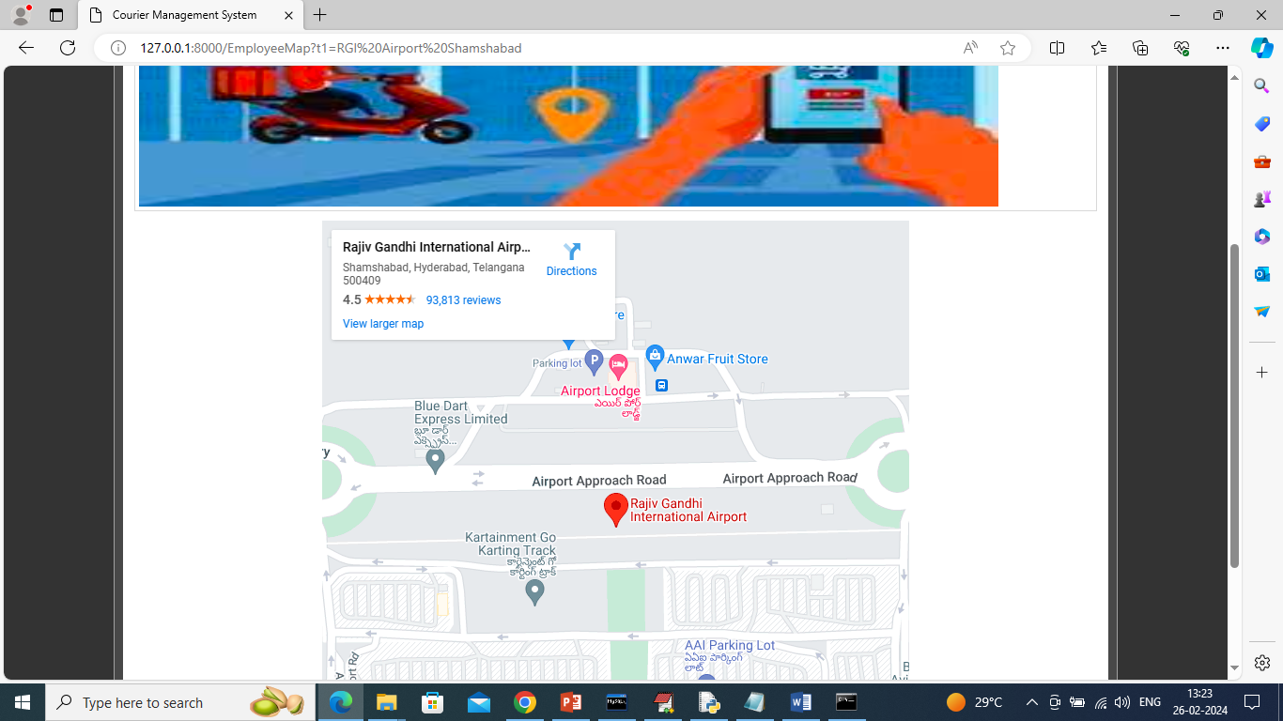

In above screen employee can see ‘courier current location was RGI Airport’. Now logout and track same with user

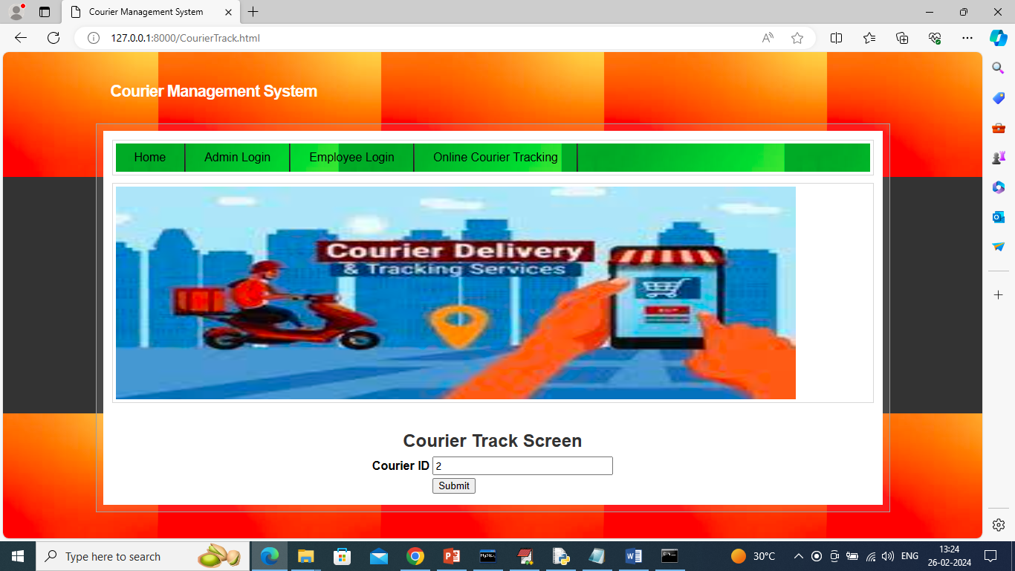

In above screen user also can track courier just by entering ID and then press button to get below page

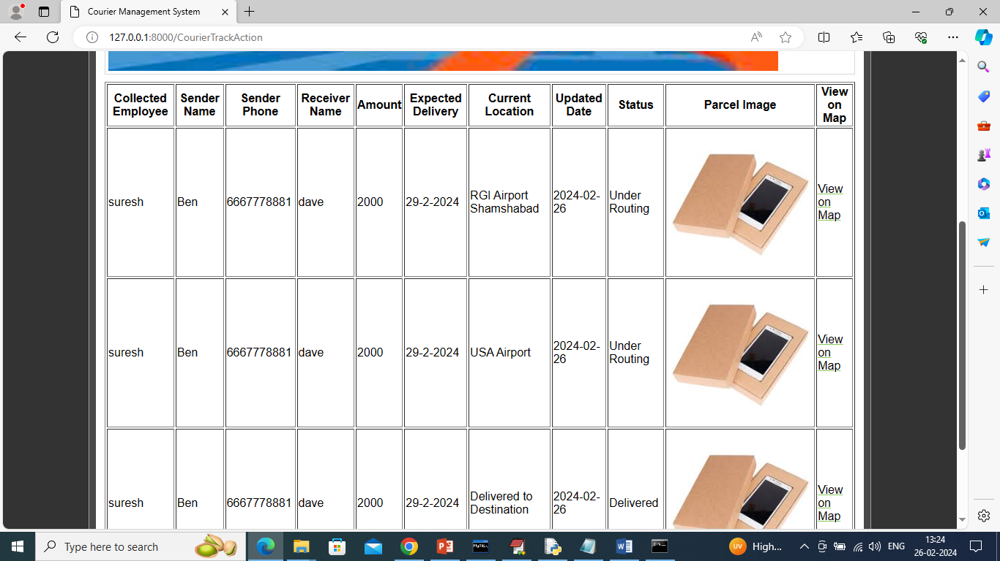

In above screen user can also see all possible location of his courier. Similarly by following above screens you can manage and run all courier system.